**PRACTICAL 11:**

**Grade of a student based on their marks**

**CODE:**

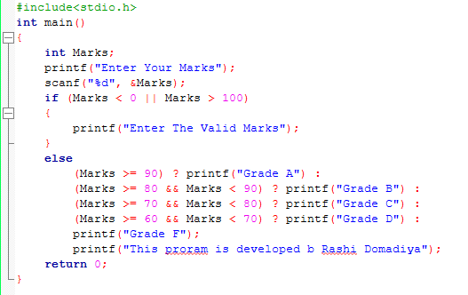

**Output:**

**Grade A:**

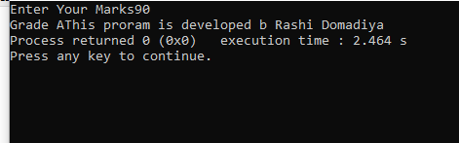

**Grade B:**

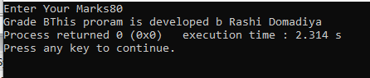

**Grade C:**

